1. **If else syntax:**

**If [expression]**

**then**

**xyz**

**Else**

**abc**

**fi**

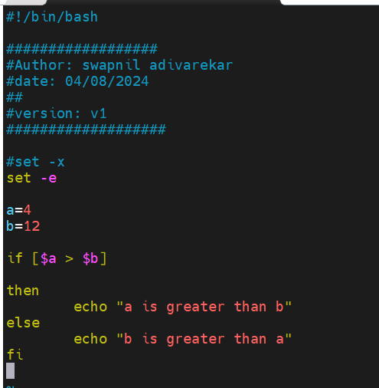

1. **For loop syntax:**

**for i in {1..10};do echo $i;done**

1. **There are lot of signals are in linux. When you are hit any command or press any key or ctrl + c then it sending signal to terminal or linux to perform the respective action.**

**Trap command traps these signals.**

**#trap ‘echo do not use ctrl+c’ SIGINT**

1. **I.Q: Print the numbers which are divisible by 2 and 3 but not 4 or print even/odd numbers. Number range in 1 to 100.**

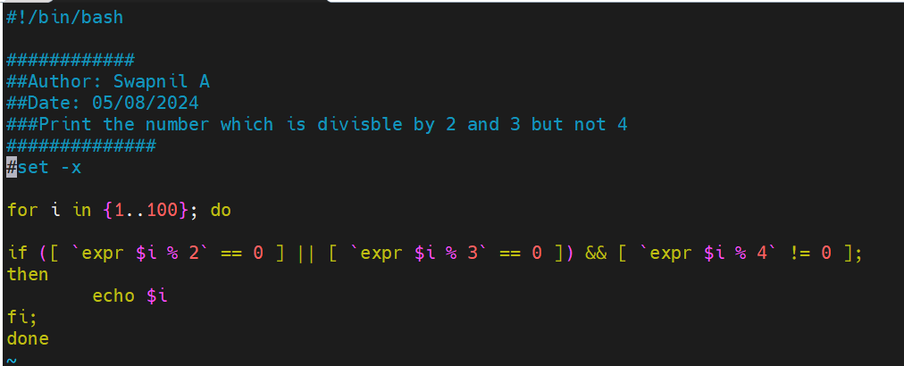

1. **I.Q: Write a script to print how many times S appeared in mississipi?**

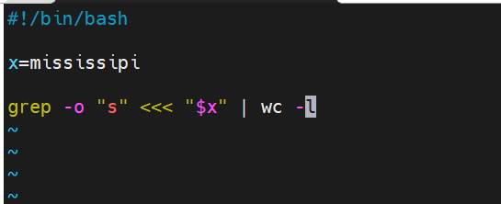

1. **I.Q: Difference between break and continue statement?**

**BREAK- breaking the execution**

**CONTINUE- Continuing the execution (Skip), skip this and continue the next**

1. **I.Q: Different types of loop?**

**For, While, Do-while**

1. **I.Q: How will you sort list of names in file?**

**Sort command is an easiest way.**

1. **I.Q: How will you manage logs of a system that generates huge log files every day?**

**Logrorate configuration.**